Dear Families,
Your child will complete their Theme Square Sheet for the learn at home assignment for September 3, 2024. These student choice boards encourage children to have a choice in their tasks. These tasks encourage creative problem solving and critical thinking skills. It is not expected that children produce a ‘perfect’ result. Instead, creations that have been well thought out and where each feature of the design can be identified and explained are highly regarded. Children can use any materials on hand to complete one chosen task from the STEM SQUARE SHEET. Using old plastic bottles, newspaper and cardboard is a good start. The tasks are kept open-ended to allow students to fulfill their innovative and creative potential. When asking to design something we do not expect actual size. For example, if asked to make a hang glider, a small/miniature version is suitable. If you have further questions, please ask your child’s teacher.
Mrs. Hollimon

Kindergarten | 1st and 2nd grades | 3rd, 4th, and 5th grades
Design a Turkey   | Design a Turkey | Design a Turkey
Build a House   | Build a House | Build a House
Make a Family Tree  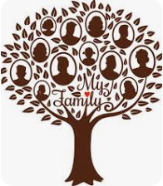 | Make a Board Game  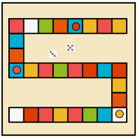 | Make a ship that floats  

